SSH into the EC2 instance created thorough terraform

1. EC2
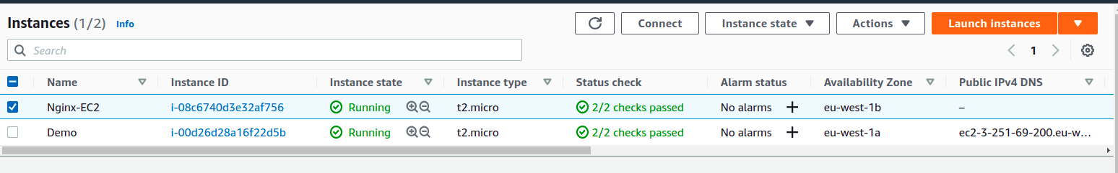
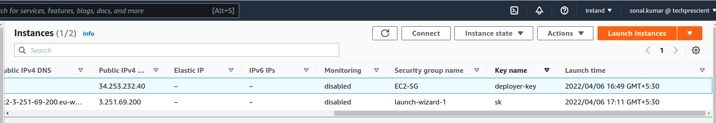
2. Now to to SSH client
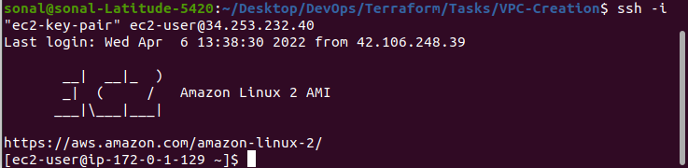
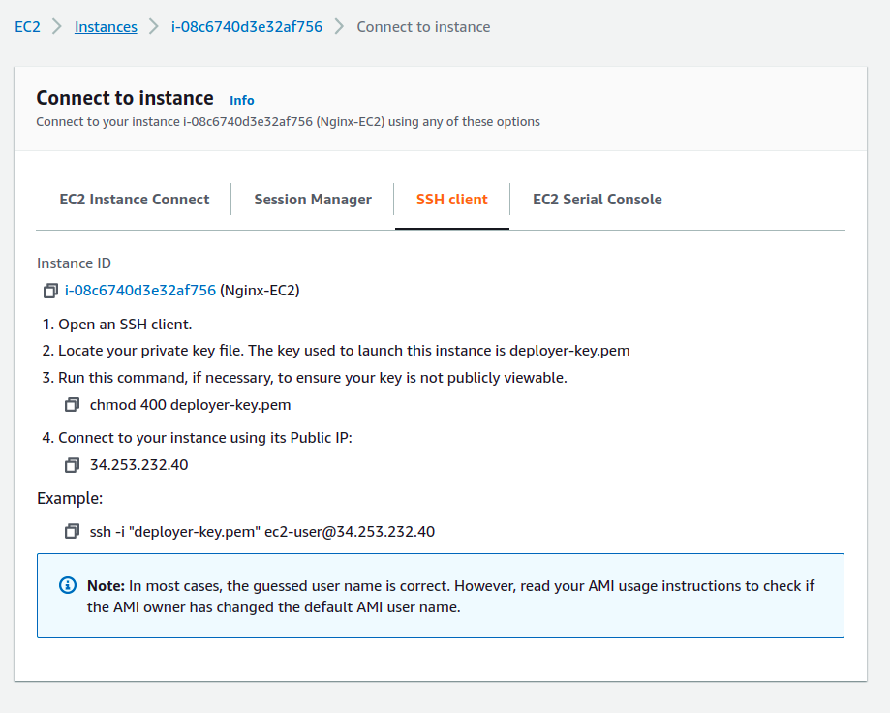
copy the example command
but modify if while running the command on terminal
as our .pem file i.e private key is names as
“ec2-key-pair” hence we’ll be using this in command insted of deployer-key.pem

